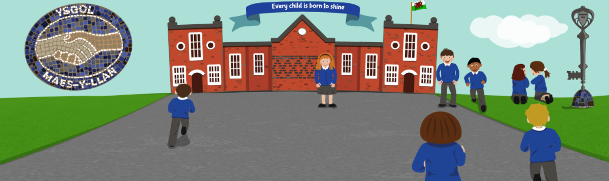
Health and Wellbeing Week Sponsored Coastal Path Walk

Name | Amount | Paid
 | £
 | £
 | £
 | £
 | £
 | £
 | £
 | £
 | £
 | £
 | £
 | £
 | £
 | £
 | £
 | £
Extra Sponsorship forms are available on the school website if required.

