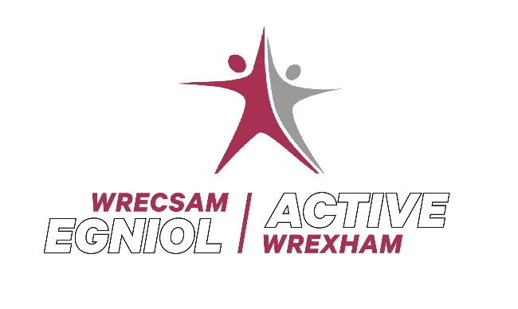

Free Swimming Lessons

Dear Parent/Guardian

Unfortunately due to Covid 19 restrictions and Public Health Wales guidance, we have not been able to deliver our school swimming programme this term.

Wrexham County Borough Council is providing free swimming lessons for children who haven’t reached the required swimming standard in their school lessons. These lessons will run during the school holidays and will be taken by qualified swimming teachers, with the benefit of having smaller class sizes with others of similar ability.
The aim of the lessons is for children to become more confident in water but also where possible to reach the required National Curriculum standard.

Plas Madoc Leisure Centre

Tuesday 1st June – Friday 4th June
4 day course
9.30am – 10.00am – Lesson 1
10.00am – 10.30am – Lesson 2

To enrol your child for these lessons please contact:

Louise Brady
Sports Development Assistant Manager
louise.brady@wrexham.gov.uk

Many Thanks
Louise

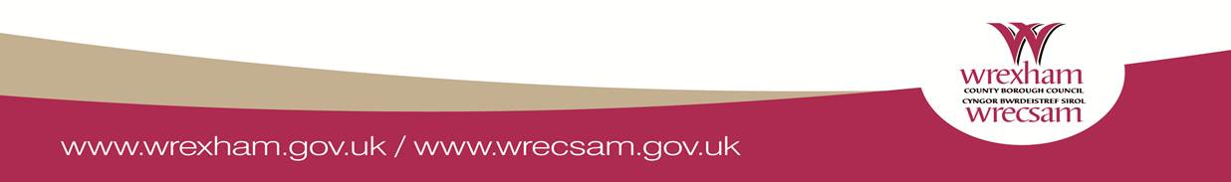
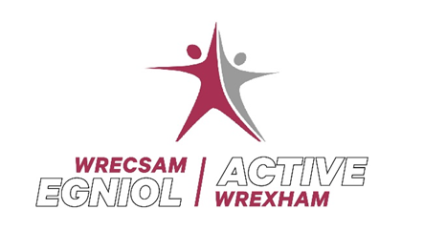
Gwersi Nofio am ddim

Annwyl Rhiant/Gwarchodwr

Yn anffodus oherwydd cyfyngiadau Covid 19 a chanllawiau Iechyd Cyhoeddus Cymru, nid ydym wedi gallu rhedeg ein rhaglen nofio ysgolion y tymor hwn

Mae Cyngor Bwrdeistref Sirol Wrecsam yn darparu gwersi ychwanegol yn rhad ac am ddim i blant nad ydynt wedi cyrraedd y safon nofio sy'n ofynnol yn eu gwersi nofio ysgol. Cynhelir y gwersi hyn yn ystod gwyliau'r ysgol gan athrawon nofio cymwysedig, gyda'r fantais o gael dosbarthiadau llai gydag eraill o allu tebyg. Nod y gwersi yw i blant ddod yn fwy hyderus yn y dŵr, ond hefyd lle bo modd, i gyrraedd safon y Cwricwlwm Cenedlaethol sy'n ofynnol.

Canolfan Hamdden Plas Madoc
Dydd Mercher 1 Mehefin - Dydd Gwener 4 Mehefin
Cwrs 4 diwrnod
9.30am – 10.00am – Gwers 1
10.00am -10.30am - Gwers 2

I gofrestru eich plentyn ar gyfer y gwersi hyn cysylltwch:

Louise Brady
Rheolwr Datblygu Chwaraeon Cynorthwyol
louise.brady@wrexham.gov.uk

Yn Gywir
Louise

