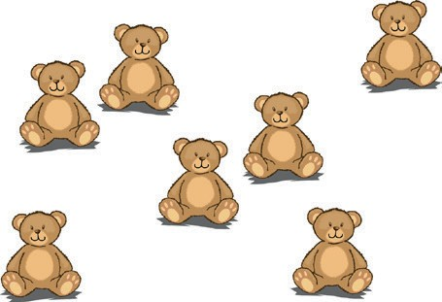
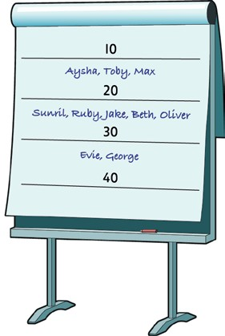
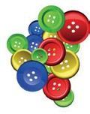
Ysgol Maes-y-Llan
 | A |  | B
Counting | How many in a set?  Estimate, and encourage estimation, within a range  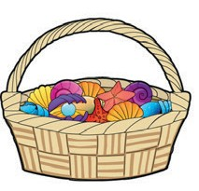 | 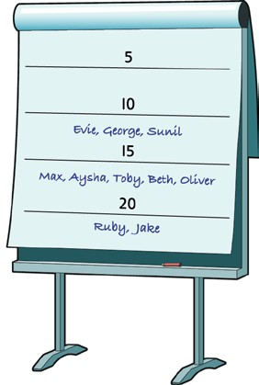 | How many in a set?  Estimate, and encourage estimation, within a range  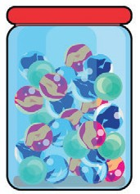  Count a large set of objects in 2s, 5s or 10s  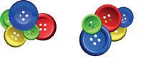  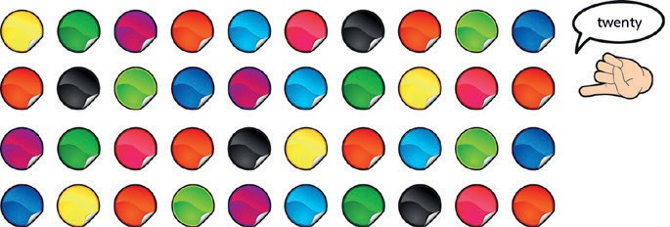
Ysgol Maes-y-Llan
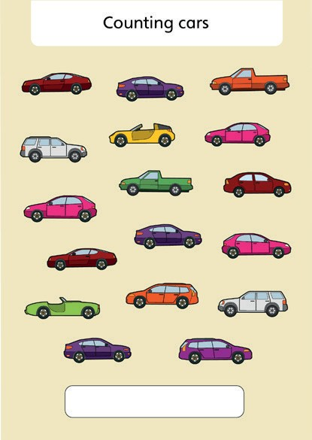
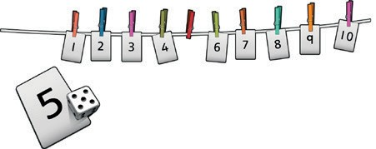
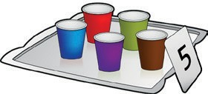
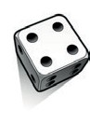
Ysgol Maes-y-Llan
 | A | B
Counting | Count, matching one-to-one  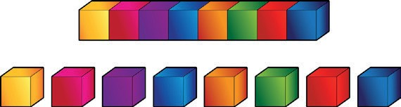  Conservation of number  Match numerals to a set of objects, sounds or images  Subitise  e.g. know there are 4 without counting 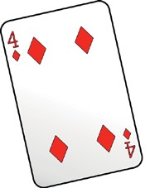 | Match numerals to a set of objects, sounds (count claps) or images  counting cars  Subitise  e.g. know there are 6 without counting  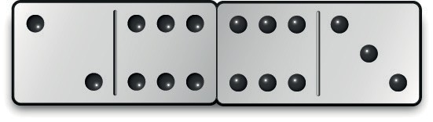
Ysgol Maes-y-Llan
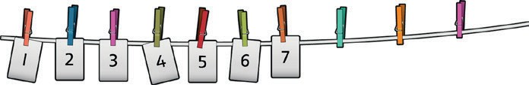
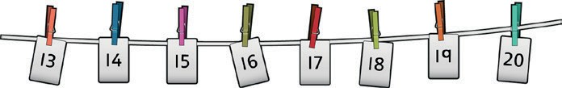
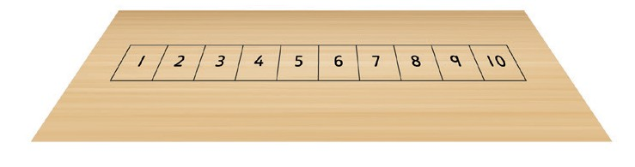
Ysgol Maes-y-Llan
 | A | B
Counting | Numbers in a line or sequence | Numbers in a line or sequence
 | Recognise numerals | Recognise numerals
 | Count along a number line or track | Count along a 100-square, spotting missing numbers
 |  | 1 2 3 4 5 6 7 8 | 9
 |  |  |  | 20
 |  | 22 23 24 25 26 27 28 | 29 | 30
 |  | 31 32 33 34 35 36 37 38 | 39 | 40
 | Spot missing numbers in the line  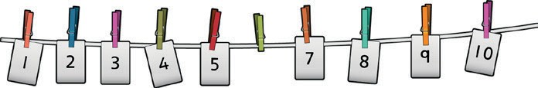 | 42 43 44 45 46 47 48 | 49 | 50
 |  | 52 53 54 55 56 57 58 | 59 | 60
 |  | 62 63 64 65 66 67 68 | 69 | 70
 |  | 71 72 73 74 75 76 77 78 | 79 | 80
 |  | 81 82 83 84 85 86 87 88 | 89 | 90
 |  | 92 93 94 95 96 97 98 | 99
Ysgol Maes-y-Llan
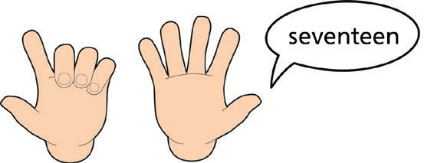
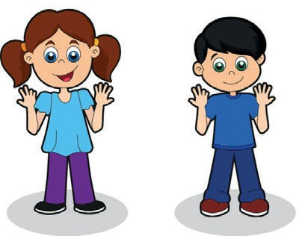
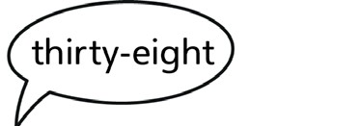
Ysgol Maes-y-Llan
1 | 2 | 3 | 4 | 5 | 6 | 7 | 8 | 9
 |  |  |  |  |  |  |  |  | 20
 | 22 | 23 | 24 | 25 | 26 | 27 | 28 | 29 | 30
31 | 32 | 33 | 34 | 35 | 36 | 37 | 38 | 39 | 40
 | 42 | 43 | 44 | 45 | 46 | 47 | 48 | 49 | 50
 | 52 | 53 | 54 | 55 | 56 | 57 | 58 | 59 | 60
 | 62 | 63 | 64 | 65 | 66 | 67 | 68 | 69 | 70
71 | 72 | 73 | 74 | 75 | 76 | 77 | 78 | 79 | 80
81 | 82 | 83 | 84 | 85 | 86 | 87 | 88 | 89 | 90
 | 92 | 93 | 94 | 95 | 96 | 97 | 98 | 99

 | A | B
Counting | Chant numbers in order to 10 and 20 Match the units to fingers  Chant numbers in order to 100 | Chant numbers in order to 100 Match the units to fingers
Ysgol Maes-y-Llan
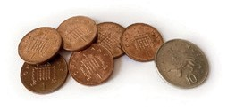
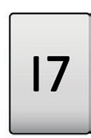
Ysgol Maes-y-Llan
1 | 2 | 3 | 4 | 5 | 6 | 7 | 8 | 9
 |  |  |  |  |  |  |  |  | 20
 | 22 | 23 | 24 | 25 | 26 | 27 | 28 | 29 | 30
31 | 32 | 33 | 34 | 35 | 36 | 37 | 38 | 39 | 40
 | 42 | 43 | 44 | 45 | 46 | 47 | 48 | 49 | 50
 | 52 | 53 | 54 | 55 | 56 | 57 | 58 | 59 | 60
 | 62 | 63 | 64 | 65 | 66 | 67 | 68 | 69 | 70
71 | 72 | 73 | 74 | 75 | 76 | 77 | 78 | 79 | 80
81 | 82 | 83 | 84 | 85 | 86 | 87 | 88 | 89 | 90
 | 92 | 93 | 94 | 95 | 96 | 97 | 98 | 99

 | A | B
Counting | Place value  Understand ‘teen’ numbers (10 to 20)  Begin to recognise 2-digit numbers  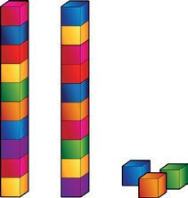  Begin to count in 10s  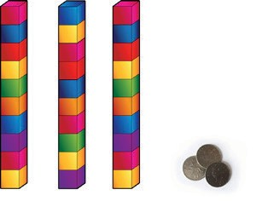 | Place value  Understand ‘teen’ numbers (10 to 20)  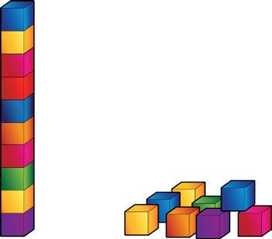  Recognise place value in 2-digit numbers  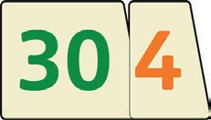  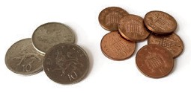
Ysgol Maes-y-Llan
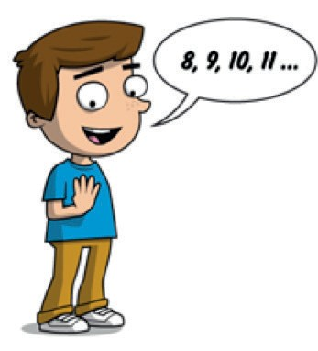
Ysgol Maes-y-Llan
 | A | B
Addition | Counting on  Count on one more, saying the next number  7 + 1 = 8  Count on 2 or 3 or 4 more from any number up to 10  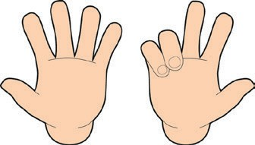  5 + 3 = 8 | Using place value  Count in 1s  e.g. 45 + 1  Count in 10s  e.g. 45 + 10 without counting on in 1s  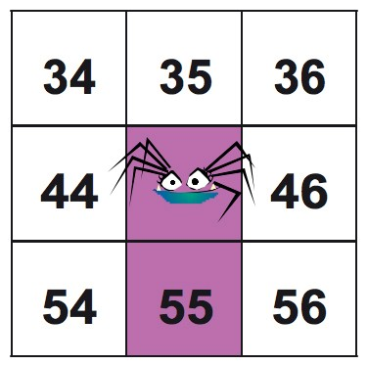  Add 10 to any given 2-digit number  Counting on  Count on in 1s  e.g. 8 + 3 as 8, 9, 10, 11  Add, putting the larger number first Count on in 10s  e.g. 45 + 20 as 45, 55, 65
Ysgol Maes-y-Llan
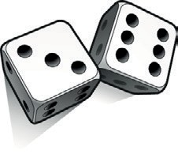
Ysgol Maes-y-Llan
 | A | B
Addition | Number bonds  Subitise  Split sets into bonds  4 + 2 = 6  4 + 3 = 7  Make small amounts  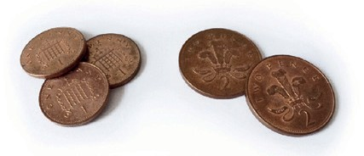 | Using number facts  ‘Story’ of 4, 5, 6, 7, 8 and 9  e.g. 7 = 7 + 0, 6 + 1, 5 + 2, 4 + 3  Number bonds to 10  e.g. 5 + 5, 6 + 4, 7 + 3, 8 + 2, 9 + 1, 10 + 0  4 + 6 = 10  Know that we can always use our fingers to work out number bonds to 10  Use patterns based on known facts when adding  e.g. 4 + 3 = 7 so we know 24 + 3 = 27, 44 + 3 = 47
Ysgol Maes-y-Llan
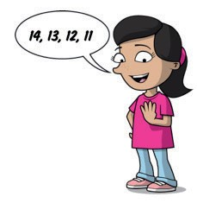
Ysgol Maes-y-Llan
 | A | B
Subtraction | Counting back  Count back 1 less, saying the number before  7 – 1 = 6  Take away 2 or 3 or 4 from any number up to 10  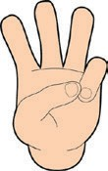  5 – 2 = 3  7 – 1 = 6 | Using place value  Count back in 1s  e.g. know 53 – 1  Count back in 10s  e.g. know 53 – 10 without counting back in 1s  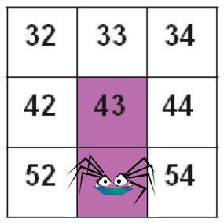  Taking away  Count back in 1s  e.g. 11 – 3 as 11, 10, 9, 8  e.g. 14 – 3 as 14, 13, 12, 11  Count back in 10s  e.g. 53 – 20 as 53, 43, 33
Ysgol Maes-y-Llan
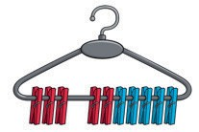
Ysgol Maes-y-Llan
 | A | B
Subtraction | Number bonds  Subitise  Split sets into bonds  6 – 2 = 4  7 – 4 = 3  Use money 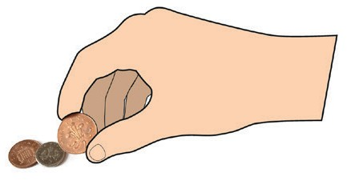 | Using number facts  'Story' of 4, 5, 6, 7, 8 and 9  e.g. 'Story' of 7 is 7 – 1 = 6, 7 – 2 = 5, 7 – 3 = 4  Number bonds to 10  e.g. 10 – 1 = 9, 10 – 2 = 8, 10 – 3 = 7  10 – 7 = 3  Subtract using patterns of known facts  e.g. 7 – 3 = 4 so we know 27 – 3 = 24, 47 – 3 = 44, 77 – 3 = 74
Ysgol Maes-y-Llan
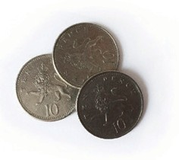
Ysgol Maes-y-Llan
 | A | B
Multiplication and division | Counting in steps ('clever counting')  Begin to count in 2s  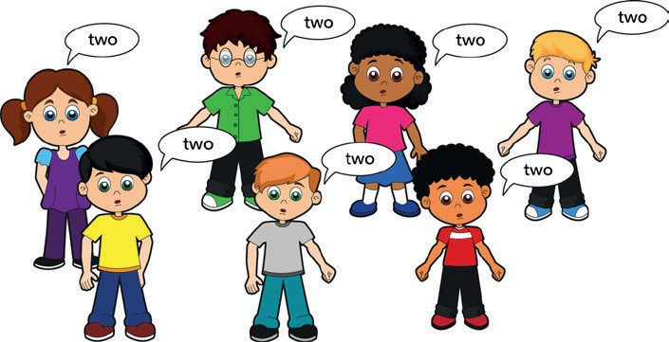  Two, four, six...  Begin to count in 5s Begin to count in 10s  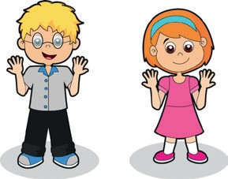  Five, ten, fifteen, twenty... Ten, twenty, thirty...  May start to sing 2, 5 and 10 times tables | Counting in steps ('clever counting')  Counting in 2s  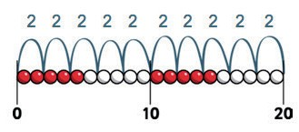  Count in 10s  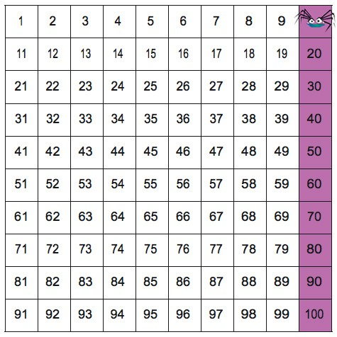
Ysgol Maes-y-Llan
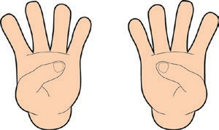
Ysgol Maes-y-Llan
 | A | B
Multiplication and division | Doubling and halving  Double numbers to 5  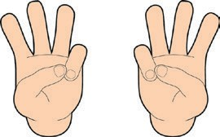  Double 3 is 6 Halve even numbers to 10  Half of 8 is 4 | Doubling and halving  Find doubles to double 5 using fingers  e.g. double 3  Find half of even numbers up to 12, including realising that it is hard to halve an odd number
Ysgol Maes-y-Llan
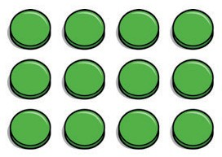
Ysgol Maes-y-Llan
 | A | B
Multiplication and division | Sharing  Share multiples of 2 and 4 into halves and quarters  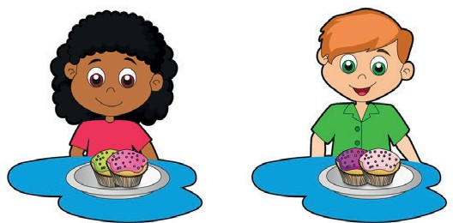 | Grouping  Begin to use visual and concrete arrays and sets of objects to find the answers to 'three lots of four' or 'two lots of five'  e.g. three lots of four  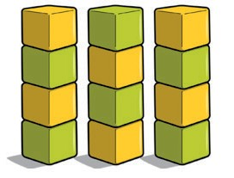  Begin to use visual and concrete arrays and sets of objects to find the answers to questions such as 'How many towers of three can I make with twelve cubes?'  Sharing  Begin to find half of a quantity using sharing  e.g. find half of 16 cubes by giving one each repeatedly to two children  Ysgol Maes-y-Llan

