Hello! I hope you all had a fantastic Easter.
For the foreseeable future, I will update this page with new work every Monday and Wednesday. The work will take the form of daily lessons and are designed to cover the whole curriculum, but please feel free to pick and choose the activities your child will engage with most. Don't forget to upload pictures and videos to Seesaw!
Each week work will be based on a different mini-theme, which I hope will hold the children's interest.
I will also upload a document with daily activities covering mental maths, vocabulary and spellings.
W/B 20th April, 2020
WB 20.04.2020 Daily Activities
Number of the day template
Look, Cover, Write, Check
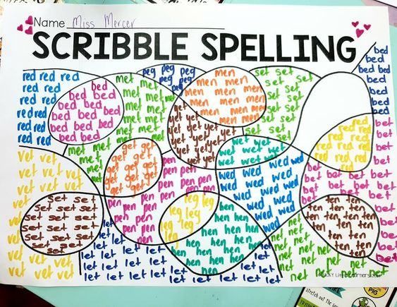
Wordsearch Template
Prefix Suffix example
Prefix Suffix
Topic Work: The Present
20 and 21 April
The Present - Discussion Questions
Story Map
Boy's Thoughts
22, 23, 24 April
Sequencing
Pets Word Mat
Jumbled Sentences
Boring Sentences
Adoption vs Buying
Mindfulness Colouring

Topic work: Sweet Cocoon
WB 27.04.2020 Daily Activities
27 and 28 April
Literacy - Setting Adjectives
Literacy - Speech bubbles
Literacy - Speech marks
Maths - Caterpillar length
Butterfly Life Cycle
29, 30, 1 May
Butterfly Art
Music - The Circle of Life
PE - Move like an insect
PSD - Friendship quiz
Similes Word Mat

Topic work: Partly Cloudy
WB 04.05.2020 Daily Activities
4,5,6,7,8 May
Baby Animals
Cloud in a Jar
Clouds
Egg or Not
Onomatopoeia
Partly Cloudy Sentence Stacking
t-ad-316-window-art_ver_1
Types of Clouds Photo Pack
Y Tywydd

Topic work: Lava
WB 11.05.2020 Daily Activities
11th-15th May
Lava lyrics
Lava Mindfulness

Topic Work: Sanjay's Super Team
WB 18.05.2020 Daily Activities
18-19 May
Chapatti Recipe
Church vs Mandir
Hindu Gods Colouring
Hindu Places of Worship
Hinduism Main Values
20-22 May
A sensory journey through India
All About India
All About Mandalas
Design a Mandala
Reading Comprehension
Where is India

Topic work: The Twits
WB 01.06.2020 Daily Activities
Plan 1st and 2nd
Mr Twit Description
Step 1 - Describing Movement
Step 1 - Describing Movement
Positive and Negative language
Step 2 - Describing Turns
Step 2 - Describing Turns
Plan 3rd, 4th, 5th
Frog Information
Frog Life cycle
Step 3 - Describing Movements and Turns
Step 3 - Describing Movements and Turns
Step 4 - Making Patterns
Step 4 - Making Patterns
Worms

Week 2

WB 08.06.2020 Daily Activities
Planning Week 2
100 Square
Balloons Graph
Balloons Tally Chart
Days of the Week
How to cure The Shrinks Example
How to write instructions
Look-Cover-Write-Check
Months of the Year
Mrs Twit's Shrinking Stick
Gn words
Lliwiau Cymraeg
Pictogram
Stretchy Objects Flaps
Week 3
Planning Week 3
WB 15.06.2020 Daily Activities
Shade-o-meter
Block 3 Step 1 Reasoning
Block 3 Step 1
Block 3 Step 1
Block 3 Step 2 Reasoning
Block 3 Step 2
Block 3 Step 2
Planning Week 3 Continued
Block 3 Step 3 Reasoning
Block 3 Step 3
Block 3 Step 3
How to take care of a bird Comprehension
Irregular Verbs
Name the Birds

Topic Work: The Enchanted Wood
WB 22.06.2020 Daily Activities
Planning Enchanted Wood 1
Train Timetable
Blank Map
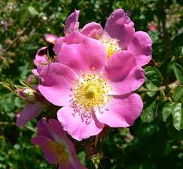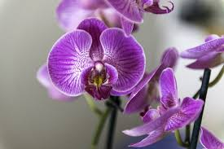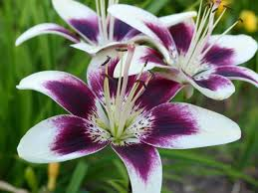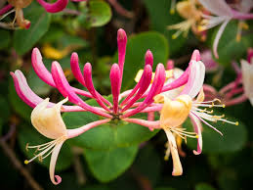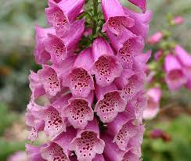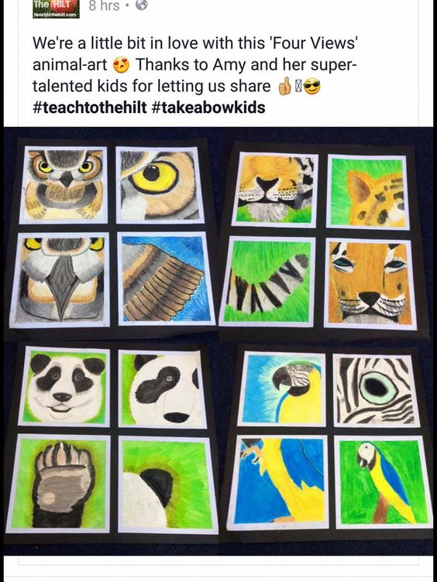
Block 3 Step 4
Reasoning
Block 3 Step 4
Block 3 Step 4
Block 3 Step 5 Reasoning
Block 3 Step 5
Block 3 Step 5
Block 3 Step 6 Reasoning
Block 3 Step 6
Block 3 Step 6
British Trees Identification
Faraway Tree Answers
Faraway Tree Comprehension
Planning Enchanted Wood 1
The Magic Faraway Tree Extract

Distance Learning - Final 2 weeks!
Literacy packs:
Y2-Emma-Elves
Y2-Quangle-F
Y2-Rainbows
Y2-Superheroes-1
Y2-Unit
Y3-Dean-Stone-Trolls
Y3-Jungle
Y3-Lockdown
Y3-Unicorn-F
Y3-Unit
Maths:
T-N-2545234-KS1-Mystery-at-the-Little-Hallow-Carnival-Maths-Game_ver_4
t-n-2545314-ks1-the-mystery-of-the-missing-macaws-at-maythorpe-zoo-maths-game_ver_6
t-n-2545887-ks1-the-mystery-of-the-missing-moji-maths-mystery-game_ver_3
t-n-2546111-ks1-the-mystery-of-the-squashed-fruit-healthy-eating-maths-mystery-game-english_ver_3
t-n-2546244-ks1-the-mystery-of-the-naughty-gnome-maths-mystery-game-english_ver_2
Other subjects
https://www.bbc.co.uk/bitesize/dailylessons

Croeso i Dosbarth Conwy!
Hello and welcome to the Spring term! We have lots of fun and interesting activities coming up this half term, so keep an eye on our Class Dojo page for updates on our learning. Below is some information you may find useful:
Tuesday - PE with Miss Thomas (pm). Please ensure your child has the correct kit in school and it is clearly labelled.
Outdoor Learning - We aim to use the outdoor environment as often as possible in order to further enhance the children’s learning. Outdoor clothing will be provided, including waterproofs and wellies.
Homework - Each child will be given a reading book and record. Reading at home will be our main homework priority this term. As a class we are having a big push on reading. The children should read their school book, but feel welcome to read a range of materials which inspire them as readers. Please can you ensure they bring their book bag in on a daily basis. The children have also requested to have homework sent weekly to help them practise skills learned in class and also some project work based on our topic. This will be sent home in a homework book on a Friday and is due back in the following Wednesday.
Snack is provided for Year 2, at a cost of £1 a week. If you do not wish for your child to have snack, please let us know. Year 3 pupils should bring their own snack from home. This should be a healthy snack in line with our Healthy Schools policy.
If parents/carers have any concerns or would like an informal chat about their child’s progress, please don’t hesitate to contact me to arrange a chat or send a message through class Class Dojo.
Below is an overview of what we will be covering this term:
Curriculum Overview Autumn 2019
Curriculum Overview Autumn 2 2019
Curriculum Overview Spring 2020
*Please note, planning is subject to change to meet the children’s needs.

