Croeso i Dosbarth Chirk
Welcome back! I hope you have all had a great Easter break. I can't believe we're at the Summer Term already- this year has flown! As always, I am super excited about the term ahead and all the amazing things planned.
We will be exploring the historical path related to the upcoming King’s Coronation.
I’m the King of the castle!
We're Going on a King Hunt...
We will be reading the following stories related to our class theme, alongside planning our own class Coronation party! During this topic we will be discussing families, capital cities, landmarks in London etc. (Please see our planning overview grid)
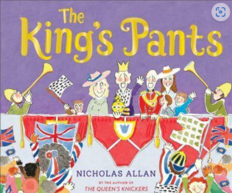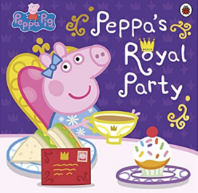
Weekly Information
Monday- Nursery/Reception: We will continue with 'Muddy Monday' with this in mind please follow the daily weather forecast closely. From a waterproof coat to suntan lotion, we do seem to be having 4 seasons in one day at the moment!
REMINDER: We will be outside whatever the weather!
Thursday- Reception: P.E day. This term we will be doing outdoor athletics in preparation for Sports Day. Reminder P.E kit is plain white t short or school logo t shirt. Navy or black shorts or tracksuit.
Please continue to read regularly at home as little as 5 minutes daily really does make a huge difference, comments in the yellow reading book are also very helpful and earn a place on the class reading wheel. We will be continuing with our 'Bookworm' reading competition next term and will be 'Spinning the Wheel' each Friday.
Feel free to contact me (between 8:30am and 4:00pm) via Class Dojo or my email address griffithss21@hwbcymru.net should you have any questions, queries or news you would like to share with me!
Thank you for your continued support.
Miss Griffiths
Click on the following link for more information about the topic:
Dosbarth Chirk - Summer 2023

Blwyddyn Newydd Dda
Spring Term 2023
A huge welcome back to Dosbarth Chirk. I hope you have all had a wonderful Christmas break and are ready for a fun, exciting term.
This first half term, the big question that we want to find out is:

What’s it like in the land of ice?
We will be using a range of new skills to investigate this question. Initially our topic will be based around the story ‘Lost and Found’ the children will then steer which direction it takes us next…… Who knows?
We will also be reading the following Winter stories ‘Lost and Found’ by Oliver Jeffers, 'Betty the Yetti' by Ella Burfoot and the classic story range by Nick Butterworth 'One Snowy Night'.
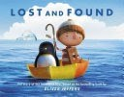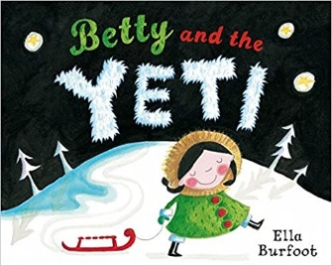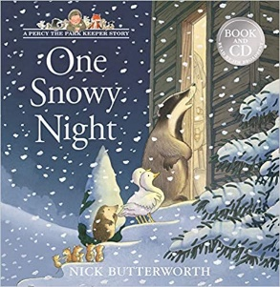
The children really enjoyed their forest school sessions last term, so each Monday we will continue our fun-filled 'Outdoor Learning' sessions, looking at nature and the changes in seasons. Children will need to come to school in their old warm clothes . Reminder we will be going outside, whatever the weather!
During the cold, wintery months our life skill will be focusing on fastening our coats and putting gloves on. Please encourage the children to be independent when dressing at home.
P.E will continue to take place on a Thursday afternoon. Children still need to come into school wearing their sports clothing on this day.
As always, If you have any questions or concerns, please feel free to contact me on Class Dojo or via email at griffithss21@hwbcymru.net
Diolch yn Fawr,
Miss Griffiths
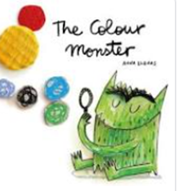
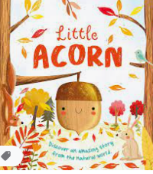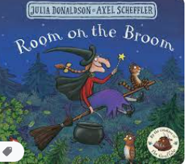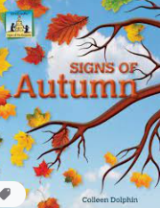
Welcome back! I hope you have all had a super summer break and are ready to start a new adventure in class Castell Chirk. I am very lucky this year to have a mixed class of both Nursery, Reception and Year 1 children. They have all made an excellent start to the year and we thank you for your support so far in helping them to settle so well. During the first few weeks, our main aims will be to get to know your child and help him/her settle in to school life. Your child’s happiness is paramount to us. We want school to be a pleasurable, exciting, fun experience, a place that your child enjoys coming to, a place where he/she can relax and be him/herself.
We have lots of exciting things planned this Autumn term, Initially the topics during the first term will based around a range of different texts with lots of links to right and wrong actions, recognising different feelings and overall well-being. Alongside this we will be completing a Baseline Assessment with all children to aid our future teaching plans.
Looking at our weekly timetable:
Muddy Monday!
We will be going into the forest school each week come rain or shine! Please send your son/daughter into school, on this day in old appropriate clothes for the weather forecast. Waterproofs and wellingtons are kept in school.
P.E. (Reception only) This will be Thursday afternoon. Please send your son/daughter into school, on this day, in their P.E kit.
Foodie Friday!
Most Fridays we will be making or baking something related to our weekly focus book. Please provide a clean, labelled take away style tub, so the children can bring the goodies home.
Book Bags (Including reading books)
To come to school on a daily basis. We are using the Go Read app to log reading. All Parents/Guardians have been given their login information, please ensure you log each read on app.
Snack
A healthy snack is available in class each morning, payments need to be made via ParentPay at £1 a week.
School Dinners (Reception)
All Reception children are eligible for FREE school dinners. Lunches must be ordered before 8am of the morning required. They can be chosen in fortnightly intervals.
If you have any questions or queries, I am available on the door in the morning or once all the children have left class in the afternoons. I am also available via Class Dojo.
I look forward to getting to know you and your children even more this term and wish you a very happy Autumn term with us.
Warmest Wishes
Miss Griffiths
Please click on the link below to see our Curriculum Overview for this term.
Dosbarth Chirk Autumn 1 2022

