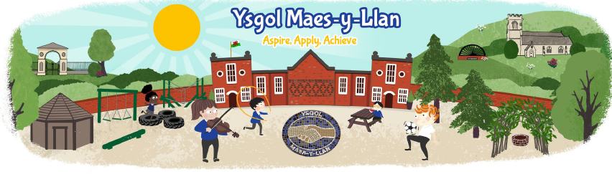

September 2023 Newsletter

**My Happy Mind**

On Monday we are launching a programme called ‘My Happy Mind’.

It is a science-backed programme to help to prepare today’s children for tomorrow’s world by building resilient, balanced and happy mind.

The children will take part in a range of activities, once a week, and complete a journal of their thoughts and feelings.



Dear Parents/Carers

Welcome to our first newsletter of the school year. I hope you all had a lovely summer holiday and I look forward to meeting you all over the coming weeks. It has been lovely visiting the classes and meeting all the children and I am slowly beginning my first task of learning all their names.

This year the children are going to be allocated times in our amazing forest school area and undertaking exciting, possibly muddy, activities. They will be able to come to school on the day in their forest school clothes. The staff will shortly be sending messages to you all through Dojo to keep you informed.

We are also updating our website and school app. This will be going live very soon!! I will be using the website to keep you all updated and to celebrate the children’s successes.

I look forward to working in partnership with you all.

Kind Regards,

Mrs Beth Rolls

Pennaeth/Headteacher

Please ensure that we have up to date contact details at school. If your details (i.e. telephone number or email address) has changed, please update on the Sims Parent App

[www.sims-parent.co.uk](http://www.sims-parent.co.uk)

A reminder that the school photographer is in school on Thursday morning

Themes for this term:

Dosbarth Chirk – All about me

Dosbarth Harlech – The Three Little Pigs

Dosbarth Conwy – Superheroes

Dosbarth Criccieth – I have a golden ticket

Dosbarth Penrhyn – Strike a pose.

Dosbarth Caerdydd – Strike a pose.

**Dates for the diary this half term:**

11th September – Launch ‘My Happy Mind’.

13th September – Assembly with PC Hulley: staying safe

14th September – Individual photographs

‘Make Some Noise’ workshop

15th September – Yr 6 Swimming

29th September – Sponsored Walk

4th October – Coffee Morning (with Cake!!)

16th & 17th October – FP parents evening

23rd & 24th  October– KS2 parents evening

27th October – Break Up



**Term Dates 2023-2024**

**Autumn Term 2023:**

Monday 1st September to Friday 27th October 2023

Monday 6th November to Wednesday 20th December 2023

Training days: 1st & 4th September; 21st & 22nd December

**Spring Term 2024:**

Monday 8th January to Friday 9th February 2024

Monday 19th February to Friday 22nd March 2024

**Summer Term 2024:**

Monday 8th April to Friday 24th May 2024

Monday 3rd June to Friday 19th July 2024

Training days: 24th May; 19th July

Applications are now open for Secondary School Places, please visit [www.wrexham.gov.uk](http://www.wrexham.gov.uk)

and follow the links from the Schools and Education page.