[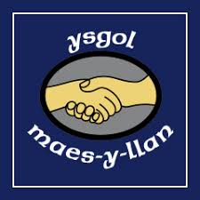](https://www.google.co.uk/imgres?imgurl=https://www.ourschoolwear.co.uk/media/catalog/category/maes-y-llan_3.jpg&imgrefurl=https://www.ourschoolwear.co.uk/primary-schools.html&docid=OEXUWIpjJsBBvM&tbnid=hTYZBAS7HkCHyM:&vet=10ahUKEwjEiI781bPWAhXFBcAKHUg1B0wQMwheKC8wLw..i&w=240&h=240&safe=strict&bih=643&biw=1024&q=maes-y-llan%20primary%20school%20wrexham&ved=0ahUKEwjEiI781bPWAhXFBcAKHUg1B0wQMwheKC8wLw&iact=mrc&uact=8)

**Early Education**

Ysgol Maes Y Llan

We are pleased to share that we are now able to offer funded Early Education in

**Ysgol Maes Y Llan**

starting January 2024.

For children who have reached the age of three before the start of spring term, a funded place will be provided for both the spring and summer terms. For children with birthdays in the spring term a funded place will be provided for the summer term.

You’ll need to apply by October 27, 2023 to be offered a place starting in spring term (January) 2024.

If your child is eligible just for the summer term you can apply from October 30, 2023. You’ll need to apply by December 29, 2023, to be offered a place starting in summer term (April) 2024.



You can apply online for a place for your child using the online admissions service at [www.wrexham.gov.uk](http://www.wrexham.gov.uk)

Or contact Funded Early Education Admissions Department

Telephone:

01978 298991

The sessions will take place Monday to Thursday 9am until 11:30am