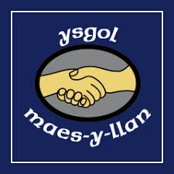
Ysgol Maes y Llan
Home School Agreement
Agreement for children
To help myself at school, I will:
Be Ready
- Arrive to school on time
- Wear the correct uniform
- Have a ‘ready to learn’ attitude
Be Respectful
- Show respect to other pupils with actions and words.
- Show respect to the adults in school.
- Be respectful of the school environment and property
Be Safe
- Move around school safety.
- Use equipment safely.
- Tell someone if you are worried or upset

Signature (child)
_______________________________________

Agreement for parents/carers
To help my child at school, I will:
- Ensure that my child attends school regularly and that absences are properly notified.
- Ensure that my child arrives and where appropriate is collected promptly at the beginning and end of the school day.
- Support the school’s policies and guidelines on behaviour and equal opportunities.
- Encourage my child to read regularly.
- Be responsible in the use of communication technology, including the use of social media and mobile phones. If you have a concern speak to us first.
- Attend Parent’s Evenings and discussions about my child’s progress at school.
Signature (parent/carer)
_______________________________________
Agreement for school
To help your child at school, we will:
- Provide a safe, friendly atmosphere.
- Encourage all children to do their best.
- Encourage them to be respectful and safe.
- Offer an exciting curriculum which is broad, balanced and meets the need of your individual child.
- Actively welcome parents/carers into the life of the school
- Keep you informed about your child’s progress and events in the school.
- Keep you informed about the school’s policies.
Signature (Staff)
Mrs B Rolls (Headteacher)

