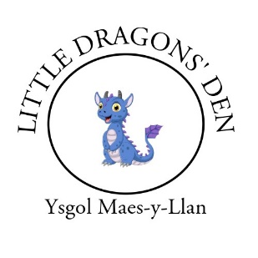

**LITTLE DRAGONS’ DEN**

**Tiny Dragons’ Wrap Around Care**

**Registration Form**

Child's Name (in full): ……………………………………………………………………………………………………………………………….

Preferred Name: ………………………………………………………………………………………………………………………………………..

Address: …………………………………………………………………………………………………………………………………………………………

Date of birth: ……………………………………………………… Gender: …………………………………………………………………

Current School: ………………………………………………………………………………………………………………

Name of Parent/Guardian: ………………………………………………………………………………………………………………………

Telephone: Home: …………………………… Work: ……………………………… Mobile: ……………………………………….

Allergies or medical conditions: ………………………………………………………………………………………

Dietary requirements: …………………………………………………………………………………………………….

**Please provide below the details of persons nominated to collect your child/ren from Tiny Dragons’ and/or who may be contacted in case of an emergency in the event of illness/accident.**

**Children will only be allowed to leave with their named contacts and not allowed to walk home alone. The club leaders must be advised beforehand of any changes to this.**

(1)Name: …………………………………………………………………………………………………………………………………………………………..

Relationship to Child: …………………………………………………………………………………………………………………………………..

Address: ………………………………………………………………………………………………………………………………………...………………..

Telephone No: ……………………………………………………………………… Email: ……………………………………………………………………

(2)Name: …………………………………………………………………………………………………………………………………………………………..

Relationship to Child: …………………………………………………………………………………………………………………………………..

Address: ………………………………………………………………………………………………………………………………………...………………..

Telephone No: …………………………………………………………………………………………………………………………………………………..…

(3)Name: …………………………………………………………………………………………………………………………………………………………..

Relationship to Child: …………………………………………………………………………………………………………………………………..

Address: ………………………………………………………………………………………………………………………………………...………………..

Telephone No: …………………………………………………………………… Email ………………………………………………………………………

**Parent/Carer Contract**

I will ensure that my child will be:

**Respectful**

* Show respect to other pupils with actions and words.
* Show respect to the adults in school.
* Be respectful of the school environment and property.

**Safe**

* Move around school safety.
* Use equipment safely.
* Tell someone if they are worried or upset.

**Emergency First Aid**

I consent to any emergency medical treatment necessary during the session in Tiny Dragons’. I authorise the staff to sign any written form of consent required by the hospital authority if the delay in getting my signature is considered by the doctor to endanger my child's health and safety.

If I require my child to be given medication by staff at Tiny Dragons’, I will provide the Supervisor with detailed instructions in writing, along with the clearly labelled medication.

I will also sign and date these written instructions.

I have read and understood the above contract. The information I have given is correct to the best of my knowledge. Should there be any changes to the information given in this document, then I will notify the Supervisor immediately in writing. I agree to abide by these terms and conditions of the agreement.

**Booking and Charges**

Booking should be made online and in advance for all sessions.

Please visit: https://schoolsays.co.uk/booking/maes-y-llan/

Fees are payable weekly in advance and the daily fee is £17.50.

Payment should be made via your Parentpay account and you will be given an activation code upon registration.

Name of Parent/Carer: ………………………………………...……………………………………………………

Signed: …………………………………………………………………. Date:………………………………………..