Our Welsh World
Class Topic Overview for Parents

What is Our Welsh World about?
This topic helps children understand who they are, where they live, and how their community in Wales has changed over time. Children explore their school, village (Ruabon), and town (Wrexham) through stories, visits, art, and hands-on activities.

What will your child be learning? 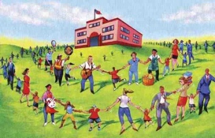
This Photo by Unknown Author is licensed under CC BY-SA-NC

Our School Community
- Who helps us in school and what their jobs are
- How we all belong to one school community
- Respecting different languages, beliefs, and cultures
- Interviewing school staff and helpers

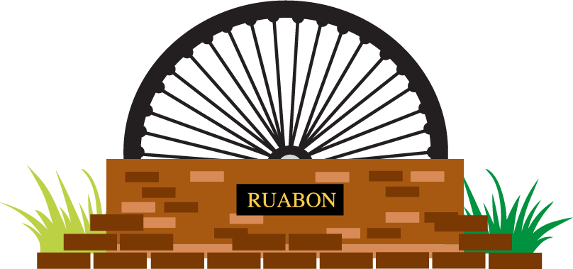 Our Village – Ruabon
- What makes Ruabon special
- Local landmarks (e.g. Ruabon mining wheel, red brick)
- Understanding local history and Cynefin (sense of belonging)
- Exploring materials used in famous local buildings

Our Town – Wrexham 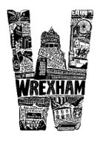
- Discovering special places in Wrexham
- Learning about the Wonders of Wales in our area
- How Wrexham has changed from past to present
- Building simple structures using different materials

Jobs Then and Now 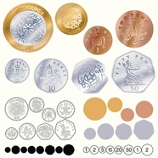

- How people earn money in our community
- Comparing past jobs (e.g. mining) with modern jobs
- Understanding how jobs have changed over time
- Using money, coins, and role-play shops

Literacy & Numeracy
- Writing letters, recounts, and diaries
- Talking about experiences and visits
- Counting, tally charts, pictograms, and bar charts
- Using money and measuring length

Home Learning – How you can help at home

Talking Together
- Talk about your job or a job someone in your family does
- Share stories about jobs in the past (grandparents / great-grandparents)

Exploring Your Area
- Go for a short walk and spot: shops, landmarks, places of work
- Take photos or draw pictures of favourite local places

Literacy at Home
- Help your child write or draw a simple letter or postcard to:
  - A family member
  - A friend
  - A school helper

Money & Maths
- Look at real coins and notes together
- Sort coins by size or colour
- Let your child help with small money totals when shopping

Creative Ideas
- Build a landmark using blocks or recycled materials
- Draw or paint something that makes Wales special
- Dress up as a job from the past or present

Thank You
Thank you for supporting your child’s learning. This topic helps children feel proud of who they are and where they come from.
If you have skills, stories, or jobs you would like to share with the class, we would love to hear from you!

Together, we are building a strong sense of belonging in our Welsh world.

