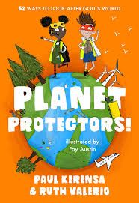
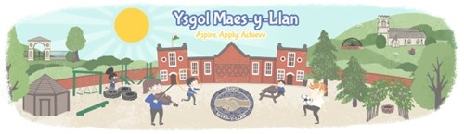

Summer Term 2026 – Dosbarth Penrhyn

Planet Protectors

‘We’ve Got the Whole World in Our Hands.’

Topic Overview
This term, our class is exploring how everyday choices affect our own wellbeing, our community and the wider world. We will be encouraging the children to see themselves as active citizens who care for their environment and make responsible decisions that support a sustainable future. We will also be having a Wellbeing Week, when our Sports Day will take place.

Why is this important?
Understanding how choices impact the environment helps children develop responsibility, empathy and a sense of belonging to their local and global community. This learning supports children to become thoughtful, confident individuals who understand that their actions matter and that they can contribute positively to the world around them.


What will we be doing?
The children will explore environmental issues beginning in our school grounds and local area and extending to the wider world. They will investigate waste, recycling, energy use and how living things depend on healthy environments. Through discussion, investigation and creative activities, they will plan ways to improve our school and community, collect and present data, and create action plans to protect our precious planet.
As we learn we will strengthen literacy skills by developing procedural (instructions) and explanation writing, creating persuasive posters, giving presentations and taking part in debates. Speaking and listening are developed through group discussion and reflection.
Mathematics and numeracy skills are developed through real-life, authentic discovery and problem-solving activities, including measuring waste and plant growth, working with fractions, telling the time, and presenting information using charts and graphs.
Within DCF (Digital Competence Framework/ IT), the children will be developing multimedia presentations, research skills and starting to reference sources used.


To plan for and action plan a reduced carbon footprint for Ysgol Maes y Llan by making a Planet Protectors Pledge.
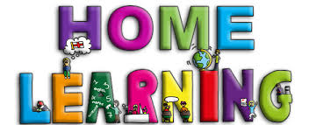

How can parents/carers support at home?
- Talk about choices at home: Discuss recycling, saving energy, reducing waste and caring for living things.
- Encourage explanation: Ask your child to explain what they have learned and why it is important.
- Use maths in everyday life: Involve your child in cooking, measuring, gardening or sorting recycling.
- Read and talk together: Share books, news stories or documentaries about nature and caring for the planet.
- Support wellbeing: Encourage outdoor activity, reflection and positive routines.

- Keep up to date: Check updates on Dojo from the school and myself for updates, up-and-coming events or celebration news.
- Help me access the full curriculum: Regularly read with your child or encourage them to read independently, and complete their Reading Record, practise their focus spellings with them and encourage them to use the Welsh language patterns that they’re using in school.
