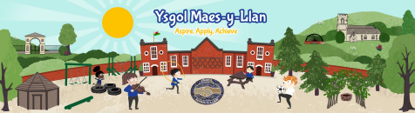
Whole School Topic: Let’s Go Global Focus: Humanities
Essential questions: What makes a place special? Should we look after the places around us?
How are places the same and different? What can we learn from people who live in different places?

Dosbarth Chirk Autumn Term 1 Class theme/ topic title: My Place, My World.
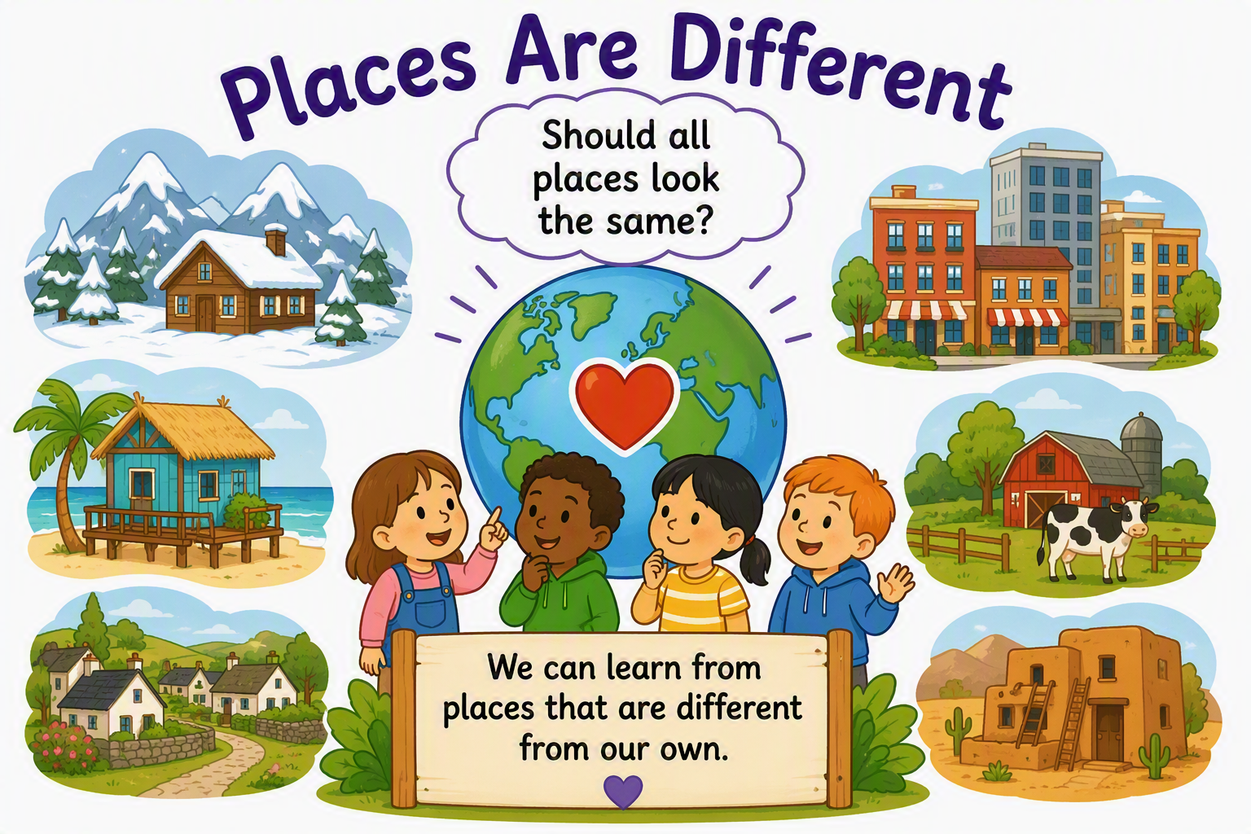
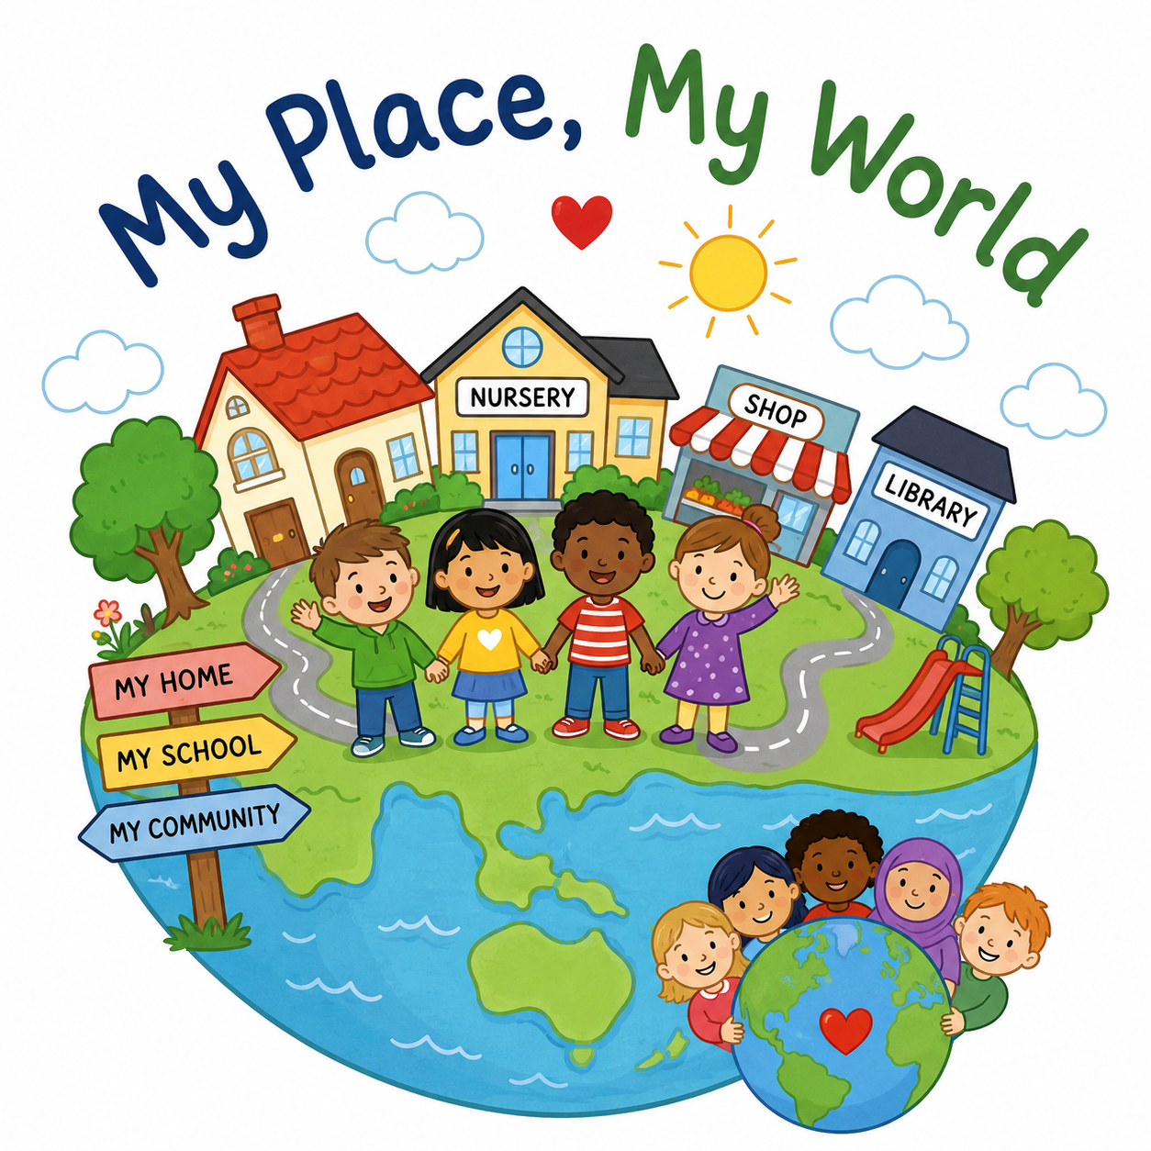
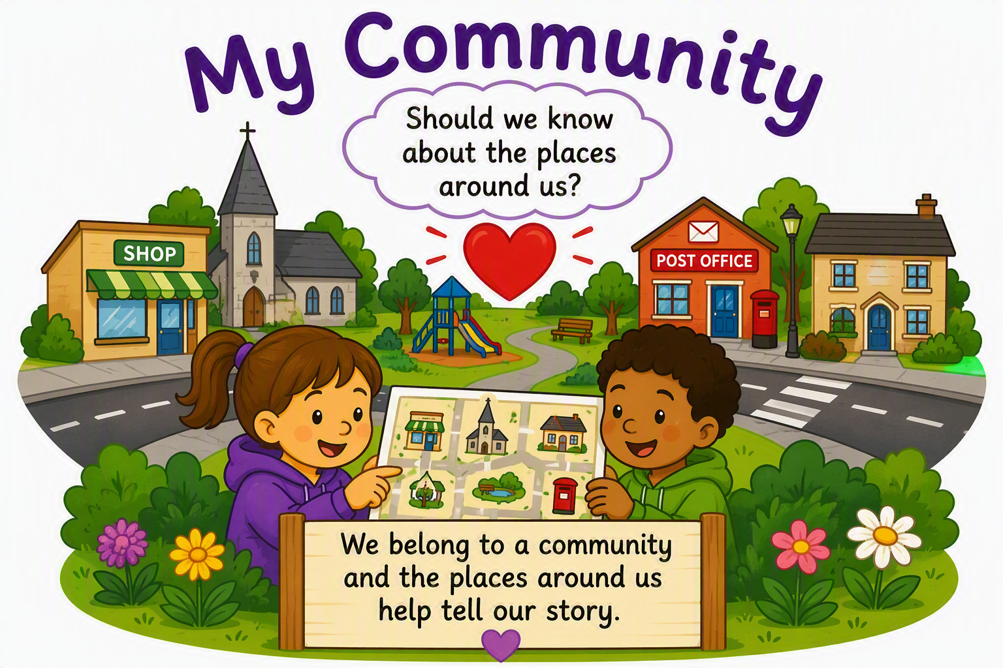
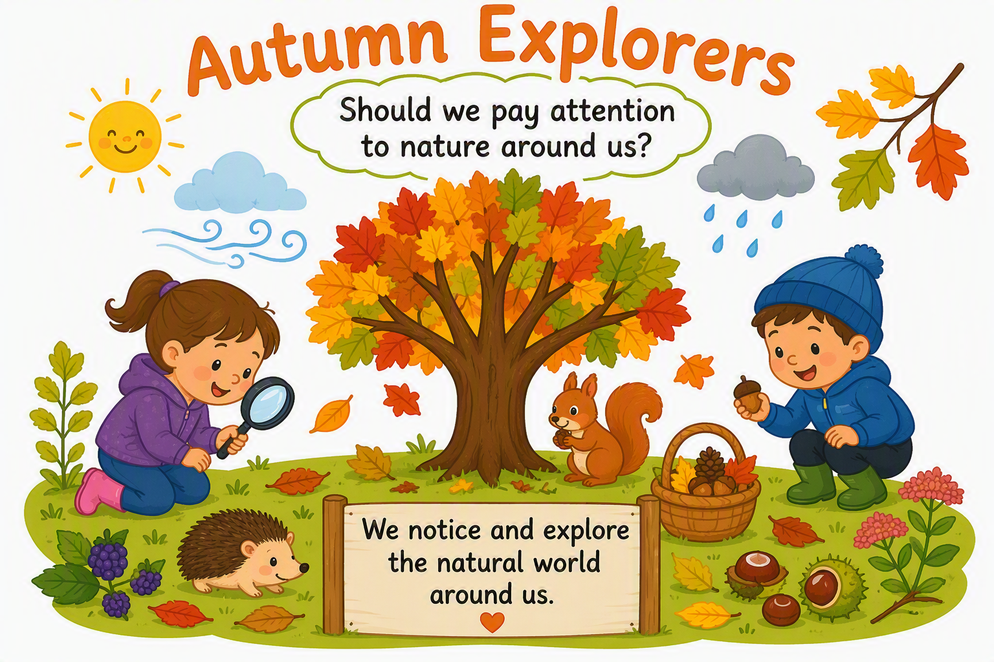
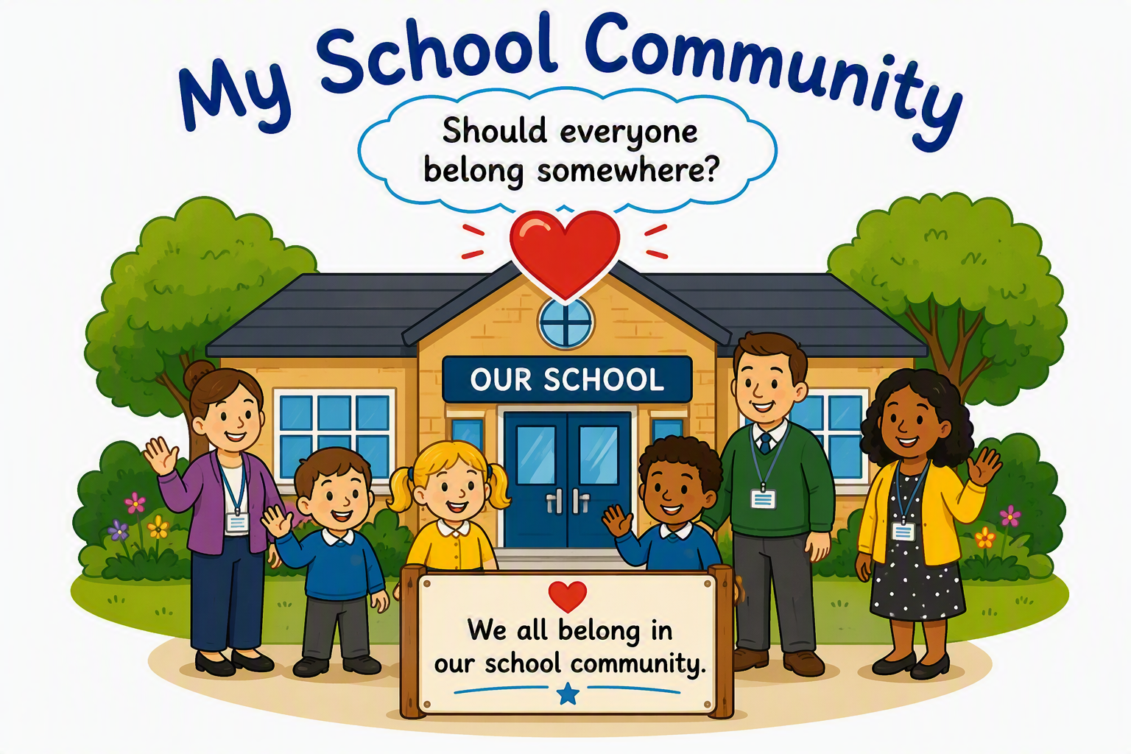
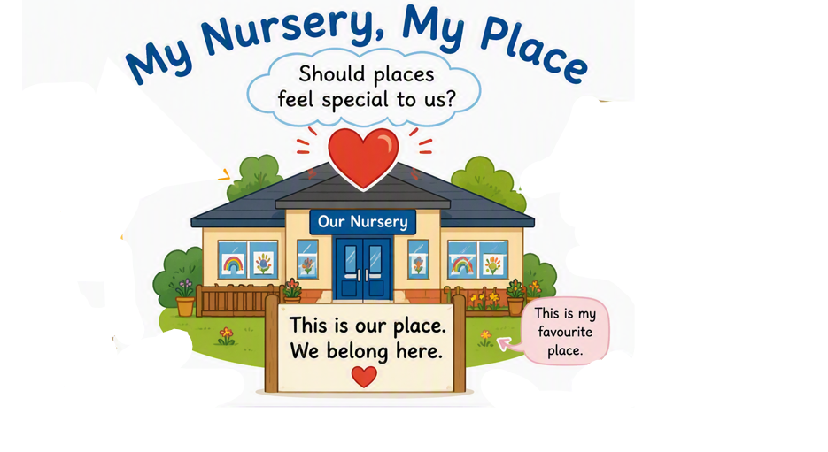

Should we care for places even if they are not our own?

Should we know about the places around us?
Should everyone belong somewhere?
Do all places look the same?

How is our world changing?
Should places feel special to us?

Why am I learning this?

- Humanities  Learners understand that the natural world is diverse and dynamic, influenced by processes and human actions.  - Health and Well-being  Learners develop their physical health and well-being has lifelong benefits.  - Languages, Literacy and Communication  Children develop vocabulary linked to place and position whilst communicating their preferences, sharing experiences and discussing places that are important to them.  - Mathematics and Numeracy  Children use positional language such as behind, next to, under and between. They begin to compare locations, count photographs and explore spatial awareness through practical experiences. | - Humanities  Children begin to recognise features of their local area and understand that places have names and purposes.  - Mathematics and Numeracy  Children compare and sort features they observe.  - Languages, Literacy and Communication Children talk about experiences and express preferences about places they visit. | - Humanities  Children explore the natural world within their locality and notice seasonal changes. They begin to make connections between themselves and their environment.  - Science and Technology Observation skills are strengthened through first-hand experiences outdoors.  - Expressive Arts  Children explore and express ideas creatively through natural materials, responding to the beauty and diversity of the world around them. | - Humanities  Children develop their understanding of familiar places within their local community and begin recognising how people and places are connected.  - Languages, Literacy and Communication  Children communicate experiences, share stories about familiar places and develop vocabulary linked to community and place.  - Health and Well-being  Children strengthen their sense of belonging, identity and connection to their community.  - Digital Competence  Children use photographs and digital devices to record observations and communicate their experiences. | - Humanities  Children begin to recognise that people live in different places and environments whilst developing an awareness of diversity and belonging.  - Languages, Literacy and Communication  Children communicate ideas, compare experiences and extend vocabulary through discussion and storytelling.  - Expressive Arts  Children respond creatively through construction, role play, music, movement and imaginative play.  - Health and Well-being  Children develop respect for others and an appreciation that everyone's experiences may be different. | - Humanities  Children develop a growing sense of responsibility for familiar places and begin to recognise that they can help care for the environments and communities to which they belong.  - Health and Wellbeing  Children develop confidence, responsibility and a sense of belonging through caring for their environment and contributing to their community.  - Science and technology  Children develop curiosity about living things and the environment through planting, observing change and exploring ways to care for the natural world.
Key Learning Experiences – My Learning Journey
We will explore:  - Explain to the children that we are going on a Nursery treasure hunt to discover different areas around the provision.  - Allow the children to use iPads to take photographs of their favourite places indoors and outdoors.  - Children create a map made from photographs of the Nursery environment.  - Take the children into the outdoor area to play hide-and-seek games using positional language such as behind, next to, under, and between.  - Use teddies or puppets to take "journeys" around Nursery, encouraging children to help them find familiar places.  - Create a floor map using large photographs and encourage children to move themselves around the map. | We will explore:  - Children visit key places throughout school:  Hall  Library  Office  Kitchen  Outdoor areas  - Children meet familiar adults around the school and find out about their roles.  For example:  Office staff  Caretaker  Kitchen staff  Headteacher  Teaching staff  Children could prepare simple questions such as:  "What do you do in school?"  - Our School Map  Building on Week 1, children create a larger map showing Nursery as part of the wider school.  Add photographs collected during walks.  - Build Our School  Children use crates, blocks and large construction equipment to create significant areas within school. | We will explore:  - Autumn Detective Walk  Take children around the school grounds looking for signs of autumn.  Children might:  Collect fallen leaves.  Find acorns, conkers and seed pods.  Notice changes in trees.  Listen for sounds outdoors.  Observe the weather.  Encourage children to talk about what they notice and compare findings.  - Nature Treasure Hunt  Challenge children to find:  Something crunchy  Something smooth  Something yellow  Something small  - Leaf Investigation Station  Provide:  Magnifying glasses  Leaves of different shapes and colours  Mirrors  Children can:  Compare leaves.  Sort leaves.  Look closely at patterns and veins.  - Leaf Printing and Rubbings  Children use leaves to:  Print patterns  Make rubbings  Create collages  Discuss similarities and differences between the leaves. | We will explore:  - Community Walk  Take children on a walk around the local area.  Children might:  Spot different types of buildings.  Notice roads, signs and pathways.  Identify familiar places they visit with their families.  - Photograph Hunt  Take photographs of familiar local places.  Children:  Match photographs to real locations.  - Create a Class Map of Our Community  Using photographs from the walk, children help create a simple map.  Children can:  Place photographs in position.  Add drawings and symbols.  Talk about journeys they make.  - Using small world, children to create different parts of Ruabon using their knowledge and the photographs they have taken. | We will explore:  - Homes Around the World  Share photographs of a range of homes such as:  Houses  Flats  Farmhouses  Cottages  Encourage children to notice and talk about similarities and differences.  - Build Different Homes  Provide:  Blocks  Natural materials  Loose parts  Construction kits  Children design and build different types of homes.  - Stories From Different Places  Read stories set in different environments.  Focus discussions on:  Where characters live  What the environment is like  Similarities to children's own experiences  - Around the World Music and Movement  Explore music and dances from a range of cultures represented within your school community.  Children can:  Move to different rhythms.  Compare sounds and instruments. | We will explore:  - Environmental Detectives  Children investigate the school grounds looking for:  Areas that are well cared for  Areas that need attention  Plants and animals  Natural habitats  Litter and waste  - Nursery and School Litter Pick  Provide gloves, grabbers and buckets.  Children:  Collect litter safely.  Sort items collected.  Discuss why litter can be harmful.  Afterwards, children can reflect on how the environment looks before and after their actions.  - Planting for the Future  Children plant:  Bulbs  Wildflower seeds  Winter flowers  - Recycling Investigation  Explore common materials:  Paper  Plastic  Cardboard  Metal  Children sort materials into groups and discuss what can be reused or recycled.
Literacy Genre Focus: Recount (oracy focused)
Week 1: My Nursery, My Place  Recount Focus  Talking about what we did.  After the Nursery treasure hunt, adults encourage children to recall:  "Where did we go?"  "What did we find?"  "Which place did you like best?" | Week 2: My School Community  Recount Focus  Retelling a journey.  Following the school walk and visits to different areas, children help recount their experience.  Adults model sequencing language:  first  then  next  after |  | Week 3: Autumn Explorers  Recount Focus  Describing what we discovered.  After autumn walks, children use photographs and collected objects to recount their exploration.  Adult prompts:  "What did you notice?"  "What did you find?"  "What happened outside today?" |  | Week 4: My Community  Recount Focus  Talking about places we visited.  Following community walks, children help create a shared recount.  For example:  "We walked past the church."  "We saw the shop."  "We found the park."  Adults support children to sequence events and discuss familiar landmarks. | Week 5: Places Are Different  Recount Focus  Sharing and comparing experiences.  Children recount stories, role-play journeys and discuss new places they have explored through photographs and books.  Adult prompts:  "What place did we learn about today?"  "How was it different?"  "What did you notice?" | Week 6: Looking After Our World  Recount Focus  Reflecting on our learning journey.  Children look back through photographs from the six weeks and help create a class recount.  For example:  "First we explored Nursery."  "Then we visited our school."  "Next we explored autumn."  "We learned about different places."  "We planted flowers."
Numeracy Coverage
Week 1: Numeracy Focus: Position and Space. Children develop spatial awareness as they explore their Nursery environment.  They begin to:  Use positional language such as in, out, next to, behind, under and between.  Follow simple directions.  Match photographs to locations.  Discuss where places are within the Nursery. |  | Week 2: Numeracy Focus: Counting and Comparing  As children explore the school environment, they begin using number in meaningful contexts.  They might:  Count classrooms, doors and windows.  Compare room sizes.  Count steps taken between locations.  Discuss which journeys are longer or shorter. |  | Week 3: Numeracy Focus: Sorting and Classifying  Children use natural materials to develop early mathematical reasoning.  They might:  Sort leaves by colour, size or shape.  Count collections of conkers and acorns.  Compare lengths of sticks.  Create repeating patterns using natural objects. | Week 4: Numeracy Focus: Direction and Mapping  Children begin to recognise that mathematics helps us understand journeys and locations.  They might:  Follow and describe routes.  Use language such as near, far, forwards, backwards, left and right.  Place photographs on a simple class map.  Compare different journeys. | Week 5: Numeracy Focus: Comparing and Measuring  Children compare different homes and environments.  They might:  Compare the heights of buildings.  Compare the sizes of homes.  Sort photographs into groups.  Compare the number of features in different environments. | Week 6: Numeracy Focus: Data Handling  Children use mathematics to answer questions about their experiences.  They might:  Count litter collected.  Sort recyclable materials.  Vote for favourite places explored throughout the topic.  Create simple pictograms using photographs or objects.
DCF: Discreet Skills to be taught
Week 1 – Exploring digital technology  Digital Den activity: Nursery – Data Data Everywhere – Supporting Role Play with Digital Applications  DCF focus: Exploring familiar software and recognising that digital technology can be used for different purposes.  What are we doing?  Introduce digital technology as something we can use to help us explore our world.  During role play, provide opportunities to use an iPad or other technology meaningfully.  For example, create a travel agency, airport, shop or holiday setting. |  | Week 2 – Being a digital creator  Digital Den activity: Nursery – Let's Create – Being A Digital Creator  DCF focus: Creating simple digital work.  What are we doing?  Introduce the idea that children can create something using technology, rather than only consuming digital content.  Children could:  •make marks on an iPad;  •create a digital picture;  •experiment with colours and tools;  •add simple images or marks. |  | Week 3 – Using technology to support mark making  Digital Den activities: Nursery – Let's Create – Creating Marks On-Screen  and/or Nursery – Working Together – Explore and Use Digital Technologies to Support Mark Making  DCF focus: Using digital technology to create and communicate.  What are we doing?  Allow children to experiment with:  • drawing;  • lines;  • shapes;  • colours;  • simple digital tools.  Encourage children to make choices and explain what they are creating. | Week 4 – Finding images  Digital Den activity: Reception – Working Together – Finding Images or Information Online  DCF focus: Finding information or images using technology, with adult support.  What are we doing?  Although this is a Reception activity, it provides an appropriate supported next step for children who are ready.  Adults model using simple search terms to find an image.  For example:  "Let's find an elephant."  "What should we type?"  Children help choose search words and discuss the results. | Week 5 – Creating a digital recount  Digital Den activities: Nursery – Let's Create – Being A Digital Creator  and Nursery – Working Together – Explore and Use Digital Technologies to Support Writing  DCF focus: Using digital technology to communicate an experience.  What are we doing?  Use photographs from a class experience and create a simple digital recount.  Children can:  •choose photographs;  •put them in an order;  •talk about what happened;  •add marks;  •record their voice. | Week 6 – Talking about our digital work  Digital Den activity: Nursery – Let's Create – Being A Digital Creator  DCF focus: Beginning to evaluate digital work.  What are we doing?  Look at children's digital creations together.  Ask:  •What did you make?  •What do you like?  •What would you change?  •What did you use?  Keep evaluation simple and verbal.  Evidence  Use:  •photographs;  •screenshots;  •pupil voice;  •observations;  •examples of digital creations.
My end goal: (authentic/ purposeful): Children recognise that they belong to their Nursery, school and local community. Through first-hand experiences, they confidently talk about familiar places, notice features of the natural world and show curiosity about places beyond their immediate experience. They demonstrate care for the environment and understand that everyone can help look after the places that matter to them.

