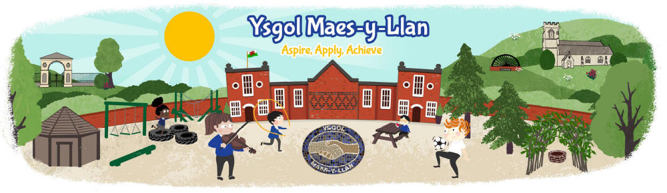

The Governor’s Annual Report to Parents
2025 to 2026

Contents:

- Welcome and Introductory message from the Chair of Governors.
- Governing Body: Meeting information, Members list.
- School Organisation: Information and Finance, Curriculum, Buildings and Security, Community.
- Our Journey.

Dear Parents and Carers,
It gives me great pleasure to present the annual report of the Governing Body for the 2025/26 academic year.
This year has been another successful one for Ysgol Maes y Llan and reflects the hard work, dedication and commitment of our pupils, staff and wider school community. We are proud of the many achievements of our learners and of the positive, nurturing environment that enables our children to learn, grow and thrive.
As governors, we are committed to supporting the school’s ongoing development and improvement. Working closely with the leadership team, we will continue to build on the school’s many strengths and strive to provide the very best opportunities and outcomes for every child at Ysgol Maes y Llan.
I would also like to express my sincere gratitude to my fellow governors, who generously give their time, expertise and support to the school. My thanks also go to all our staff for the high-quality care, guidance and education they provide each day, making a positive difference to the wellbeing and achievement of our pupils.
Finally, I would like to thank you, our parents and carers, for your continued support and partnership. Your involvement plays a vital role in the success of our pupils and strengthens our whole school community.

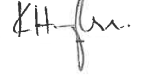
Yours sincerely,
Mr Kevin Hughes
Chair of the Governing Body

Governing Body Meeting Information.
- We meet as a full Governing Body once per term, with the key business of receiving updates on standards, resources, and milestone tasks being main items of the agenda. Our role during these meetings is to receive updates/information from the HT/SLT/staff or governor on how the school is performing and provide an independent oversight of the management and operation of the school with the aim of helping to improve the quality of education and raising standards by being a ‘critical friend’. We do not run the school on a day-to-day basis; that is the job of the Headteacher and senior staff.
- For other business, such as appointing new teaching or Senior Leadership Team staff, finance, personnel issues, etc, we meet as committees. All of the Governing body members are part of designated committees that meet as required.
- We are proactive in terms of visiting the school, involving ourselves in learning walks, attending staff meetings, at least every term.

Chair of Governors
(Community Governor): Mr Kevin Hughes
c/o Ysgol Maes-y-Llan, Maes-y-Llan Lane,
Ruabon. LL14 6AE. Tel: 01978 820991

Vice Chair of Governors
(Parent Governor): Mrs Melissa Evans

Headteacher Governor: Mrs Beth Rolls

Teacher Governor: Miss Hannah Postle

Staff Governor: Mrs Gemma Tilston

Parent Governors: Miss Cat Williams
Mr Wayne Callaghan
Mrs Lyndsey George

Community Governors: Mr Kevin Hughes
Ms Pam Hallam
Mrs Samantha Jesson

LA Governor: Mr James Harris
Mrs Claire Caldwell

Clerk to the Governors: Mrs Debbie Carson (contact at the school)

The Parent Governor was elected on 22nd June 2026 and the next election for a Parent Governor will take place in advance of 22nd October 2028.

Staffing
Senior Leadership Team
Mrs Beth Rolls – Headteacher, Designated Safeguarding Person (DSP)
Mrs Jo Gruffydd – Deputy Headteacher, Literacy lead, Assessment & Progression lead, Deputy Designated Safeguarding Person, Student Mentor, Behaviour lead, Year 4/5 teacher
Mrs Belinda Jackson – ALNCo, Year Rec & 1/2 teacher, Health and Wellbeing lead, EAL lead, Happiness Heroes lead

Teaching staff
Mrs Amy Guiel – Year 2/3 teacher, DCF lead, RWInc lead, Science & Technology lead
Mrs Emma Roberts – Part time Rec & 1/2 teacher
Miss Hannah Postle – Maternity
Mrs Rhian Steele – Year 5/6 teacher, Maths & Numeracy lead, RSE, Student Mentor, Criw Cymraeg lead

Learning Support
Mrs Rebecca Jones – Part time Level 3 TA within KS2/HLTA PPA cover
Mrs Gemma Tilston – HLTA Nursery, HLTA PPA cover, ELSA
Miss Lisa Callaghan – Full time Level 3 TA within Rec & 1/2 TA, After School Club lead
Miss Rabia Zafar – Full Time Level 1 Rec & 1/2 TA, Breakfast Club lead
Mrs Julie Strange – Full time Level 2 TA within Year 2/3 class
Miss Sue Edwards – Part time Level 1 TA within Nursery

Administration staff
Mrs Debbie Carson – Full time School Business Manager

Other staff
Mrs Kim Jones – Cook
Miss Kadie Jones– Cook’s assistant
Miss Beckie Lewis – Cook’s assistant
Mr Jonathan Shaw – Caretaker/Cleaner
Mrs Evelyn Agyemang – Cleaner

Class Organisation
The school had 5 classes which were all mixed age ranges.
Dosbarth | Number of children | Teacher | Teaching Assistants
Chirk | 10 | Mrs Rolls (overseeing) | Mrs Tilston HLTA  Miss Sue Edwards
Conwy | 26 | Mrs Belinda Jackson (Mon, Tues, Wed am)  Mrs Emma Roberts (Wed pm, Thurs, Fri) | Miss Lisa Callaghan  Miss Rabia Zafar
Criccieth | 23 | Mrs Amy Guiel | Mrs Julie Strange (1:1)
Penrhyn | 32 | Mrs Jo Gruffydd | Mrs Rebecca Jones
Caerdydd | 32 | Mrs Rhian Steele | Mrs Rebecca Jones

School Sessions
Early Education Sessions 8:50am – 11:30am 4 mornings per week
Nursery Sessions 8:50am. – 11.30am. 5 mornings per week
Statutory School Age: FP - 8.50am. – 11:45am, KS2 8:50am – 12 noon
and 12.45p.m. – 3.00p.m.

Attendance
Our attendance status for the 2025/26 school year can be found below:
Headline Figures (03/09/2025 - 20/07/2026)

We continue to engage with the Education Welfare Service with regard to supporting and managing attendance and punctuality. We follow a graduated response with regard to pupils who have persistent absence or lateness, which includes welfare support and use of Fixed Penalty Notices as a last resort.

Additional Learning Needs & Inclusion
Some children during their time in primary school experience difficulties in specific areas of learning.
At Maes-y-Llan, our aim is to identify and assess, as early as possible, all children who have an additional educational need. This results in the school being able to make provision for them so that an appropriate level of work and the right amount of support is provided to allow them to access the curriculum.
We are proud of the systems we have in place which together, with our dedicated staff, allow us to identify needs early and to put in place suitable support.
Children with identified additional needs will have specific targets to work towards and will have a personalised plan drawn up, suited to their level of need. Close liaison between the teacher, parents and our Additional Learning Needs Co-ordinator (ALNCO), Mrs Jackson, ensures that all parties work together to try to achieve the targets. Appropriate support and / or interventions will be implemented and regularly reviewed in school.
We work very closely alongside a wide range of outside agencies such as the Education Psychologist, Speech and Language services, Sensory Support, Action for Children, Social Services etc., to provide specialised support for individual children. Regular review meetings take place with parents.
Accessibility
Ramps are situated in various parts of the school to allow access for all pupils; there is also accessible toilet provision for both adults and pupils who require this. There is complete access at ground floor level for all pupils and adults. The school has established an Accessibility Plan, Equalities Policy and Strategic Equality Action Plan. The school engages with Children’s Services as required for support/guidance relating to safeguarding and child protection.
Health & Safety
The school holds regular fire drills.
School Toilets
The school has several toilets for pupils and staff.
Nursery and Reception pupils have access to toilets within their classroom. These are all self-contained cubicles and these are mixed toilets for boys and girls. Year 1 and 2 pupils have separate toilets close to their classrooms and there are individual toilets for boys and girls. KS2 pupils have boys’ and girls’ toilets located close to their classrooms. The school also has an accessible toilet. All toilets are cleaned daily.
Extra-curricular activities
The school enjoys a range of extra-curricular activities after school. These have been exceptionally popular this year and have included Football, Digital Club, Arts and Craft, Cookery Club, Super Ambassadors and Gardening Club. Pupils have had the opportunity to experience a wide range of trips.
Promotion of healthy eating and drinking by pupils
The school catering team follow Welsh Government guidelines regarding providing a healthy menu. All school meals (hot and cold) are prepared on site and the catering team is managed by the Local Authority. All pupils are encouraged to bring a healthy snack to school and have access to water throughout the day. The school communicates the importance of healthy eating and drinking to pupils as part of the school curriculum. During the 2025/26 school year, the school continued to work successfully with the Local Authority Healthy Schools Service to develop health and wellbeing across the school.

Community links
The school enjoys strong links with the wider community. Visitors are regularly welcomed to the school to enrich and enhance both the curricular and extra-curricular offering. The Police School Liaison Officer also visits the school regularly and delivers sessions with pupils in all year groups.
School leavers
The majority of pupils leaving year 6 transitioning to Ysgol Rhiwabon High School.

Term Dates
Autumn Term 2025:
Monday 1st September - Friday 24th October 2025
Monday 3rd November - Friday 19th December 2025
Training days: 1st and 2nd September

Spring Term 2026:
Monday 5th January - Friday 13th February 2026
Monday 23rd February - Friday 27th March 2026
Training day: 5th January
Summer Term 2026:
Monday 13th April - Friday 22nd May 2026
Monday 1st June - Monday 20th July 2026
Training days: 13th April, 26th June and 20th July.

School Prospectus
Copies of the prospectus are available on request from the school office or can be found on the school website.
https://maesyllan-pri.wrexham.sch.uk/key-information/policies/

Policies

The school has a current Accessibility Policy, Equalities Policy and Strategic Equalities Plan. During the current academic year, the following school policies have been amended and updated as per the school policy review schedule:

Policy
Develop Healthy Relationships and Behaviour Policy
Parent Code of Conduct
Dignity at Work Policy
Grievance Policy
Whistleblowing Policy
Disciplinary Policy
Safeguarding Policy
Toileting Policy
Uniform Policy
Educational Visits Policy
ALN Policy
Health and Safety Policy
Pay Policy
Professional Development Policy
Cluster Transition Plan
Directed Time Policy

2025/26 School Financial Statement (School Budget)
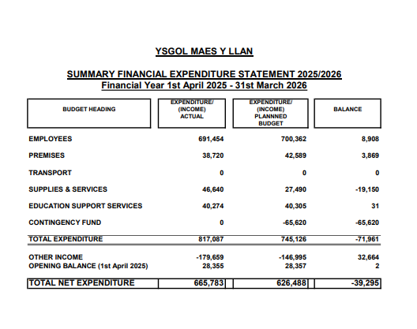

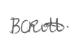
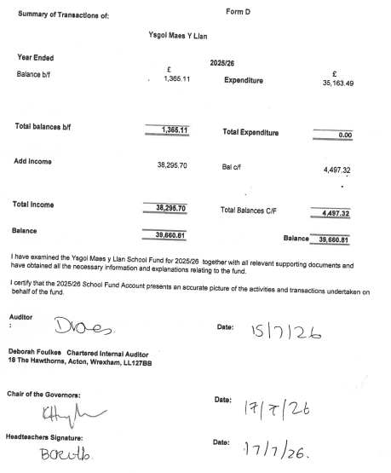
24/10/25

School Development
Evaluating School Improvement Priorities 2025 to 2026:
Priority | Evaluation | Next steps
Priority 1: To raise standards in Welsh Oracy skills throughout the school | - Met with LA advisory teacher who shared ideas of how to move forwards.  - Created a plan of improvement  - Undertaken an audit of the use of Bob Dydd as a baseline  - Staff undertaken Helpwr Heddiw Training.  - Learning Walk taken place to monitor the use of Welsh within the classrooms  - Criw Cymraeg put in place  - Staff meeting planned to look at how we plan Welsh, to ensure progress.  - Continued to use the Tocyn Iaith to promote the use of Welsh with children and staff.  - Visit undertaken by LA advisory teacher to review Bob Dydd chart and support Welsh Lead on next steps.  - Teaching staff have completed training linked to their phase group.  - Children have in Foundation Phase have learnt the Jambori songs  - The non-negotiables have been shared with governors.  - Staff continue to use the Language continuum for planning of phrases. | - To continue to develop Criw Cymraeg with planned meetings with SLT on how to continue to develop Welsh Oracy throughout the school and beyond.  - Criw Cymraeg to take aspects/whole school assemblies.  - To develop phase 3 language immersion phrases.  - To review Helpwr Heddiw  Priority ongoing –  Priority 1: To raise standards in Welsh Oracy skills throughout the school
Priority 2: Plan opportunities for pupils to develop their digital skills progressively and to apply their digital skills across the curriculum. | - Our Digital Lead has conducted a survey of staff’s confidence and training needs.  - Mrs Guiel has attended training for AI.  - We have formed a Digital Leads group and they have held their first meeting.  - We have planned training of the use of AI I the classroom for the training day in January.  - Identified focus area of DCF – Citizenship, to be taught and evidenced this term.  - Have decided to teach DCF as a discreet lesson to ensure of the teaching of skills and a progression of skills across the curriculum.  - Held a parent ICT workshop focusing on online safety, use of Apps in the classroom, sharing examples of ICT work and undertaking an activity on coding. | - To continue to use Digital Den as support for teachers.  - To continue to teach ICT skills discreetly  - To monitor and collect examples of work to monitor progress  Priority Achieved – will continue monitor and adapt when needed and when the budget allows. Will monitor through priority planning and examples of work.
Priority 3: To strengthen and embed opportunities for pupils to apply and develop their numeracy skills across the curriculum, enabling them to become ambitious, capable learners who can use mathematics confidently in real-life and cross-disciplinary contexts. | - Undertaken the Curriculum Design Course to adapt medium term planning to focus on the ‘why’ rather than the ‘what’.  - Have begun collecting evidence of examples of numeracy across the curriculum linking to medium term planning.  - Began the cluster collaboration project ‘Primed for Success’  - Have reflected on a Maths Area within classes.  - Sharing of good practice through visiting a school setting with continuous provision within KS2.  - Have planned to develop this priority across cluster September 2026 | - To develop the cluster project ‘Primmed for Success across the school.  - To review the development of mathematical skills across the school  Priority ongoing –  To strengthen and embed opportunities for pupils to apply and develop their numeracy skills across the curriculum,
Priority 4: To ensure all pupils are appropriately challenged and provided with meaningful opportunities to develop, apply, and extend their skills independently across the curriculum. | - We have added to our long-term plan which highlights the AoLEs we will be focusing on for assessment.  - We have held staff meetings looking at progression across the curriculum.  - Staff plan for opportunities for pupils to deepen their understanding through independent activities across the AoLEs.  - SLT monitor progress of focussed elements through PPMs.  - We are developing areas of the outside provision.  - Curriculum storyboard planning designs training project carried out by BR/ JG to be rolled out through CPD to rest of staff, developing medium-term plans that are pupil-led, and with four purposes and integral skills at the heart.  - Collation of progressive AfL strategies bank still ongoing, in the formulation of roadmaps.  - Completed road-maps/ progressive document for AfL strategies.  - Draft Assessment and Feedback policy completed.  - Pupil Progress transition meetings taken place to ensure smooth start to September.  - Provided CPD on self and peer assessment – sharing progressive AfL document containing exemplars. | - To implement the roadmaps in each class to support teachers.  - Will review self and peer assessment.  Priority Achieved – will continue to embed and use strategies implemented this year. Will monitor through book scrutiny and Pupil progress meetings.

Welsh Government Language Category
Ysgol Maes y Llan is currently in Language Category 1 as classified by the Welsh Government. This category means that the school is a ‘predominantly English medium school’. Although English is the main language of daily teaching and learning, there is a significant focus on the use of the Welsh language.
The school is actively engaged in the Cymraeg Campus Scheme and has achieved both the Bronze and Silver award. During the current school year, the school has commenced working with the Welsh Immersion Service of the Local Authority to develop Cymraeg across the school and across all curriculum areas.

Leadership & Monitoring of Standards
At Ysgol Maes-y-Llan we value our very committed distributed leadership which includes the Headteacher and Deputy, ALNCo, Teachers, TAs and the Governing Body, who all help to drive the school forward, creating the vision and providing the strategic direction of the school.

Monitoring and school improvement is driven by having a robust Self Evaluation Report (SER) which works in connection with our School Development Plan (SDP).

In order to secure improvement for all children and to show continuity and progression, the following are undertaken through a monitoring yearly timetable.

Pupil Progress Meetings
These are termly meeting led by the Deputy Headteacher, which allow for detailed professional dialogue on every child within a class. It allows to identify strengths, and highlight where insufficient progress is being made, and the factors affecting this. Target children are identified and action plans are put in place.

Learning Walks
These are led by the Headteacher, Senior Leadership Team and often include representation from the Governing Body, School Council and the school’s assigned SIA (School Improvement Advisor, every school in Wales is assigned a SIA from their local consortia). This enables leaders to observe what they can see, hear and feel, across every class in school.

Book Looks
This is carried out by members of the Senior Leadership Team/ AoLE leads, Governors and often the school’s assigned SIA (Adviser from GwE, the North Wales Consortia) at different times of the year.

Staff Training
As part of whole school priorities and continuing professional development, staff have attended courses (including virtual), meetings (including virtual), and observations or taken part in working parties.

Our Journey
Finally, I would just like to add that the GB consider the school to be in a strong position going forward. We have made fantastic progress this year and we hope by continuing the journey together we will continue to ensure that our children will …

‘Aspire, Apply, Achieve!’

The Schools Standards and Organisation (Wales) Act 2013 (The Act) removed the requirement for school Governing Bodies to hold an annual meeting with parents.
Instead, new arrangements were introduced to enable parents to request up to 3 meetings in any school year with a Governing Body, provided that the purpose of the meetings is to discuss issues which relate to the school, not individual pupil progress and achievement or grievances against a member of staff or the governing body. At Ysgol Maes y Llan, the Governing Body will continue to produce an annual written report to parents/carers and provide an opportunity for parents/carers to meet with Governors to present the report on request.

