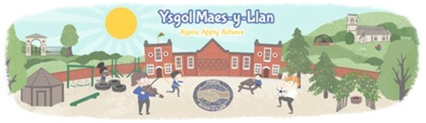

Autumn Term 2026 – Dosbarth Chirk

Little Snail, Big Journey
This term the children in Dosbarth Conwy will be embarking on an exciting learning journey inspired by the story The Snail and the Whale. Together, we will travel around the world through stories, exploration, creativity and outdoor learning, discovering different places, habitats and environments along the way.
This topic encourages children to develop a sense of curiosity about the wider world while helping them understand where they belong within it. Through the adventures of the snail and the whale, children will explore maps, oceans, forests, mountains, beaches and other environments, comparing these places with their own local area in Wales.

Why are we focusing on this?
Young children learn best through meaningful experiences that connect new ideas to their own lives. By exploring familiar places first and then discovering new places from around the world, children will:
- develop an understanding of their local community and the wider world
- build curiosity and wonder about different environments
- learn how living things depend on suitable habitats
- develop empathy, kindness and responsibility through caring for people, animals and the environment
- begin to understand how they can help protect our planet.

What will children experience?
During this learning journey, children will:
- explore maps, globes and photographs of different places around the world
- follow the whale's journey across oceans and continents
- investigate snails and other living things in our local environment
- take part in outdoor learning, nature walks and habitat hunts
- carry out scientific investigations, including floating and sinking activities
- create artwork, collages, paintings and models inspired by the story
- discuss ways we can care for animals, habitats and oceans
- develop speaking, listening, literacy and numeracy skills through engaging, hands-on experiences.

Literacy Focus
Our writing focus this term will be recount writing. Children will learn how to retell events in the correct order using time words such as:
- First
- Next
- Then
- Finally
They will create simple travel diaries and recounts based on the adventures of the snail and whale, culminating in their own independent recount writing.

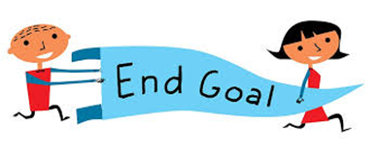
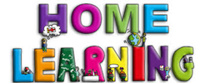
By the end of the topic, children will reflect on all the places they have explored and create a recount of their journey:

How can you support this learning at home?
You can support your child by:
- reading and talking about journeys, travel and different places
- looking at maps or globes together
- encouraging your child to notice and talk about the natural world around them
- visiting local parks, beaches or woodland areas
- discussing ways we can care for animals and the environment
- asking questions such as:
  - "Where would you like to travel?"
  - "What did the snail discover?"
  - "How can we help look after our world?"
These simple conversations help children make connections between their school learning and the world around them. [
Thank you for supporting your child's learning journey. If you have any questions about Little Snail, Big Journey, please feel free to speak to a member of the team.
Thank you for your continued support.

Kind regards,
The Dosbarth Conwy Team
Ysgol Maes y Llan

