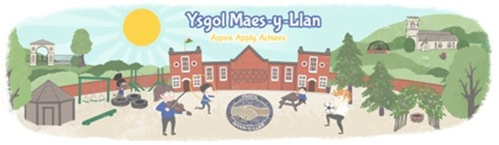
Autumn Term 1 – Let’s Go Global
What makes our world so varied and interesting?
Topic Overview
This half term, the children in our class will be exploring Let’s Go Global, a topic that helps them discover how varied and interesting our world is. They will explore different places, people, animals and environments, and learn how maps, globes and digital tools help us understand the world.
Children will compare Wales and Kenya, looking at landscapes, weather, wildlife, homes, food and traditions. They will also explore continents and oceans, develop their geographical vocabulary, and think about how learning about other cultures can help us become kind, curious and ethical citizens of the world.

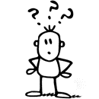Why are we focusing on this?
This topic gives children opportunities to develop their understanding of the world around them while building curiosity, respect and confidence. It helps them:
- understand that the world is made up of many different places, people, animals and environments
- use maps, atlases, globes and digital tools to locate and explore places
- compare Wales and Kenya fairly and respectfully
- understand how landscapes, weather and climate can affect people, plants and animals
Through this work, children begin to see themselves as:
- curious learners who ask questions about the world
- respectful citizens who value different cultures and ways of life
- confident explorers who can use information and digital tools to make sense of places
This supports children in becoming informed, ethical citizens and develops their ability to compare, question, communicate and work with others.

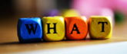 What will children experience?
During this topic, children will:
- explore different world environments, including rainforests, deserts, mountains and cities
- use maps, globes and digital tools to investigate countries, continents and oceans
- compare Wales and Kenya through their landscapes, weather, habitats and wildlife
- create artwork, fact cards, maps, surveys and other work inspired by places around the world
- develop their literacy through non-chronological reports, recounts and postcards
- develop mathematical skills including place value, comparing and ordering numbers, rounding and addition
Children will also practise Welsh through feelings, weather and personal information, and develop digital skills through searching for information, combining media and working with shared online documents.
How will learning be approached?
Learning will be active, practical and collaborative. Children will learn through exploration, discussion, research and creative tasks such as:
- using maps, globes and digital mapping tools to locate and compare places
- sorting, classifying and matching animals, habitats and geographical information
- researching information and presenting findings through writing, charts, surveys and digital media
- creating artwork inspired by world colours, landscapes, animals and habitats
- working together to solve problems, share ideas and reflect on their learning
This approach helps children develop curiosity, teamwork, communication, digital competence and a growing understanding of their place in the wider world.

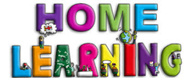How can you support this learning at home?
You can support your child by:
- looking at a map or globe together and finding Wales, Kenya, the continents and oceans
- talking about how weather and climate can affect what people, plants and animals do
- encouraging your child to share what they have discovered about another country or culture
- asking open questions such as “What is special about Wales?” “What might be different about life in Kenya?” or “How can we be kind and respectful to people who live differently to us?”
These conversations help children build curiosity, geographical vocabulary and respect for the people, places and environments they are learning about.
If you have any questions about our Let’s Go Global topic or would like to know more about your child’s learning, please feel free to speak to us.
Thank you for your continued support.
